INDEPENDENT UNIVERSITY, BANGLADESH
Department of Electrical and Electronic Engineering
EEE 234 — Electronics
PROJECT 5
Light-Activated Automatic Street Light with Microcontroller-Based Fault Detection
Design, Analysis and Proteus 8 Simulation Report
Submitted by
Erfan
Student ID: 2411830
Section: 01
Submitted to
Dr. Kazi Naziba Tahsin
Date of Submission: 14 July 2026

ABSTRACT
This report presents the design, analysis and simulation of an automatic street light controller that switches a lamp on when ambient light falls below a set level and off again at daybreak. The sensing element is a light-dependent resistor (LDR) in a voltage divider; the decision element is one half of an LM358 dual operational amplifier operating as a comparator. A potentiometer sets the switching threshold, a positive-feedback resistor introduces hysteresis so that the output cannot chatter near the trip point, and a capacitor at the sensing node rejects brief optical transients such as passing headlights. The comparator output drives a BC547 transistor which energises a 12 V relay; the relay contact switches the lamp, and a freewheeling diode protects the transistor from coil back-EMF. Two indicator LEDs report the sensor state, and a two-switch arrangement provides manual force-on and force-off override independent of the sensor. The complete circuit was captured and simulated in Proteus 8. The netlist passed Electrical Rule Check with no errors, and all four operating states were verified. Measured node voltages give a hysteresis band of approximately 0.53 V referred to the sensing divider, corresponding to LDR trip resistances of 9.31 kΩ and 11.11 kΩ. As an added feature, an ATmega328P microcontroller was integrated as an independent fault monitor that detects a failed lamp, indicator LED, or sensor, raises an audible and visual alarm, keeps a timestamped serial log, and distinguishes real faults from intentional manual overrides; every fault mode was injected and correctly identified in simulation. A section is reserved for the hardware implementation, which will be completed and appended to this report.
Keywords—LDR, comparator, LM358, hysteresis, Schmitt trigger, relay driver, street light, fault detection, ATmega328P, Proteus.

TABLE OF CONTENTS
1. Introduction 5
1.1 Background 5
1.2 Problem statement 5
1.3 Objectives 5
1.4 Scope of this report 5
2. Design Methodology 6
2.1 System overview 6
2.2 Light-sensing network (R1, LDR1) 6
2.3 Reference network (RV1) 6
2.4 Comparator with hysteresis (U1:A, R4) 7
2.5 Input noise filtering (C1) 7
2.6 Transistor driver stage (R3, Q1) 8
2.7 Relay, freewheeling diode and load switching (RL1, D1, L1) 8
2.8 Status indication (R2/D2, R5/D3) 9
2.9 Manual override (SW1, SW2) 9
3. Complete Circuit Diagram 10
4. Component Description and Function 11
5. Circuit Operation 12
5.1 Automatic mode 12
5.2 Manual override 12
6. Simulation Setup and Results 13
6.1 Simulation environment 13
6.2 Electrical rule check 13
6.3 Case A — Daylight, automatic mode 13
6.4 Case B — Darkness, automatic mode 13
6.5 Case C — Daylight with forced-on override 14
6.6 Case D — Darkness with master cut-off 14
6.7 Hysteresis measurement 15
6.8 Summary of results 15
7. Bill of Materials 16
8. Performance Analysis 17
8.1 Power budget 17
8.2 Design margins 17
9. Additional Feature: Microcontroller-Based Fault Detection 18
9.1 Design philosophy 18
9.2 Interfacing the microcontroller safely 18
9.3 How each fault is detected 18
9.4 Alerting and indication 19
9.5 Serial fault log 20
9.6 Override-aware operation 20
9.7 Complete circuit with fault-detection subsystem 21
9.8 Simulation and verification 22
9.9 Bill of materials — added subsystem 24
10. Hardware Implementation 25
9.1 Component procurement and substitutions 25
9.2 Breadboard prototype 25
9.3 Threshold calibration 25
9.4 Measured results 25
9.5 Functional verification 26
9.6 Discussion of deviations 26
11. Discussion and Limitations 27
12. Future Work 27
13. Conclusion 28
References 29
Appendix A — Electrical Rule Check (base controller) 30
Appendix B — Electrical Rule Check (with fault-detection subsystem) 31
Appendix C — Complete Bill of Materials (Proteus-generated) 32
Appendix D — Fault-Detection Firmware Listing 33

(In Microsoft Word, right-click the table above and choose “Update Field” → “Update entire table” to populate the page numbers.)

1. Introduction

1.1 Background
Street lighting is one of the largest single consumers of municipal electricity. Where lamps are switched by hand or run on a fixed clock, they are frequently left burning after sunrise or switched on before they are needed, which wastes energy and shortens lamp life. An automatic controller removes the human operator from the loop: it measures the ambient light level continuously and switches the lamp only when darkness genuinely warrants it. Because the quantity being measured (illuminance) is analogue and the required output (lamp on or lamp off) is binary, the natural circuit for the job is a comparator, which is the central element of the design presented here.

1.2 Problem statement
A simple comparator driving a lamp has two well-known weaknesses. First, at dusk the ambient light changes very slowly, so the sensing voltage can sit almost exactly at the comparator threshold for several minutes; any small fluctuation then flips the output repeatedly, and the relay and lamp chatter. Second, a momentary optical disturbance — a vehicle's headlights sweeping across the sensor, a bird, a passing shadow — can cross the threshold for a fraction of a second and cause a false transition. Both defects must be addressed for the controller to be usable rather than merely functional.

1.3 Objectives
- To design a comparator-based light-sensing circuit that switches a lamp ON in darkness and OFF in daylight, with a user-adjustable threshold.
- To eliminate output chatter near the switching point by introducing controlled positive feedback (hysteresis).
- To reject short optical transients by low-pass filtering the sensing node.
- To drive a mains-capable load safely through a transistor and relay, with proper inductive-kickback protection.
- To provide visual indication of the sensor state and a manual override that can force the lamp on or off irrespective of the sensor.
- To capture, simulate and verify the complete design in Proteus 8, and to validate the design equations against measured simulation data.

1.4 Scope of this report
Sections 2 to 8 cover the design, the circuit, the operation of every component, and the complete set of simulation results. Section 9 is reserved for the hardware implementation and is intentionally left as a structured placeholder to be completed after the physical prototype is built and tested. Sections 10 to 12 discuss limitations, further improvements and conclusions.

2. Design Methodology

2.1 System overview
The controller is built as a chain of five stages. A sensing stage converts illuminance into a voltage. A reference stage produces an adjustable comparison voltage. A comparator stage decides which of the two is larger and produces a saturated logic-level output. A driver stage converts that output into enough current to operate an electromechanical relay. Finally, a load stage routes power to the lamp through the relay contact and through the manual override switches. Indicator LEDs are tapped from the comparator output and from the driver collector so that both the sensor decision and the driver state are visible without instruments.
The supply is a single 12 V rail (BAT1). A single supply was chosen deliberately: it matches what a real outdoor controller would be given, and it forces the design to keep every node inside the LM358's input common-mode range, which extends down to the negative rail and is therefore well suited to single-supply operation.

2.2 Light-sensing network (R1, LDR1)
R1 (10 kΩ) is connected from the +12 V rail to node A, and LDR1 is connected from node A to ground. The LDR is placed in the lower leg so that its resistance rises in darkness and the voltage at node A rises with it. This gives a sensing voltage that increases monotonically with darkness, which is the polarity required to make “dark” correspond to a HIGH comparator output. Neglecting the feedback and filter components for the moment:
V_{A} = V_{CC} × R_{LDR} / ( R₁ + R_{LDR} ) (1)
The value of R1 was set equal to the LDR's approximate resistance at twilight (about 10 kΩ) so that the divider sits near mid-rail exactly when the decision must be made. This maximises the available voltage swing on either side of the threshold and therefore maximises noise immunity. Table I lists the resulting sensing voltage across the LDR's working range.
Table I. Sensing-node voltage versus LDR resistance
Ambient condition | Approx. R(LDR) | V(A) from (1)
Bright daylight | 1 kΩ | 1.09 V
Overcast day | 5 kΩ | 4.00 V
Twilight (design point) | 10 kΩ | 6.00 V
Late dusk | 20 kΩ | 8.00 V
Full darkness | 100 kΩ | 10.91 V

2.3 Reference network (RV1)
RV1, a 10 kΩ potentiometer, is connected end-to-end across the supply and its wiper feeds the inverting input (pin 2). The wiper voltage is therefore continuously adjustable from 0 V to 12 V, and the trip point of the whole controller can be set anywhere in the LDR's usable range. With the wiper at 50 % the reference is 6.00 V, which by Table I corresponds to a trip at an LDR resistance of about 10 kΩ — the twilight condition. Simulation confirms this: the measured inverting-input voltage is 5.974 V to 6.000 V depending on the exact rail voltage.
Making the threshold adjustable rather than fixed is not a convenience feature. Commercial LDRs have wide manufacturing tolerances, and the light level regarded as “dark enough” depends on the installation site. A fixed resistor divider would require the resistor to be re-selected for every unit; a potentiometer allows the same board to be calibrated in the field.

2.4 Comparator with hysteresis (U1:A, R4)
Node A drives the non-inverting input (pin 3) of U1:A and RV1's wiper drives the inverting input (pin 2). The op-amp is used open-loop as a comparator, so its output saturates near the positive rail when V(A) exceeds the reference (darkness) and near ground when it does not (daylight).
R4 (100 kΩ) is connected from the output back to the non-inverting input. This is positive feedback, and it converts the plain comparator into an inverting-free Schmitt trigger: once the output has switched, the feedback pushes node A further in the direction it has just moved, so the input must travel back through a finite band before the output can return. Applying KCL at node A at the instant of switching, when V(A) equals the reference V(ref):
R_{LDR(trip)} = V_{ref} / [ ( V_{CC} − V_{ref} ) / R₁ + ( V_{out} − V_{ref} ) / R₄ ] (2)
Substituting the simulated output levels, V(OH) = 10.44 V and V(OL) ≈ 0 V, with V(ref) = 6.00 V, R1 = 10 kΩ and R4 = 100 kΩ gives the two trip resistances:
R_{LDR(on)} = 6 / (0.600 mA − 0.060 mA) = 11.11 kΩ (darkening) (3)
R_{LDR(off)} = 6 / (0.600 mA + 0.0444 mA) = 9.31 kΩ (brightening) (4)
Referred back through (1), these correspond to sensing voltages of 6.32 V (upper trip point) and 5.79 V (lower trip point), so the hysteresis band is:
ΔV = 6.32 − 5.79 = 0.53 V (5)
A useful cross-check is the small-signal approximation, in which the band is the output swing divided down by the feedback network and the Thevenin resistance of the sensing node:
ΔV ≈ ( V_{OH} − V_{OL} ) × R_{th} / ( R_{th} + R₄ ) = 10.44 × 5.0 / 105.0 ≈ 0.50 V (6)
The two methods agree to within 6 %, which validates the choice of R4. The band is deliberately narrow. A wider band (a smaller R4) would make the lamp switch on and off at visibly different light levels, which is unrealistic for a dusk sensor; a much narrower band (a larger R4) would not provide enough immunity to keep the relay from chattering. 100 kΩ places the controller at a defensible compromise: roughly a 19 % window in LDR resistance about the trip point.

2.5 Input noise filtering (C1)
C1 (10 µF) is placed from node A to ground, in parallel with the LDR. Together with the Thevenin resistance seen at node A it forms a first-order low-pass filter. At the trip point the LDR is about 10.2 kΩ, so:
R_{th} = R₁ ∥ R_{LDR} ∥ R₄ = 10 k ∥ 10.2 k ∥ 100 k = 4.81 kΩ (7)
τ = R_{th}C₁ = 4.81 kΩ × 10 µF = 48.1 ms (8)
f_{c} = 1 / (2πR_{th}C₁) = 3.3 Hz (9)
The filter's role is complementary to that of the hysteresis, and the distinction matters. Hysteresis rejects small-amplitude noise of any duration; the filter rejects short-duration disturbances of any amplitude. A car's headlight beam sweeping the sensor is a large, brief event: it would cross the hysteresis band easily, but it is far shorter than 48 ms of settling and is therefore attenuated before it reaches the comparator. The natural day-night transition, by contrast, takes tens of minutes and passes through the filter unaffected.
It should be noted that this filtering action cannot be demonstrated by moving the light-source slider with a mouse, because a manual slider movement is itself far slower than the filter's time constant. Verifying it properly requires an injected pulse and a transient graph, which is identified in Section 11 as further work.

2.6 Transistor driver stage (R3, Q1)
The LM358 cannot source the tens of milliamperes a relay coil requires, so Q1 (BC547, NPN) is used as a low-side switch in common-emitter configuration. R3 (1 kΩ) limits the base current:
I_{B} = ( V_{OH} − V_{BE} ) / R₃ = (10.44 − 0.7) / 1 kΩ = 9.74 mA (10)
The relay's coil current sets the required collector current. Taking the nominal coil resistance of the 12 V G2R-1-E variant as approximately 275 Ω:
I_{C} = ( V_{CC} − V_{CE(sat)} ) / R_{coil} = (12 − 0.2) / 275 Ω ≈ 43 mA (11)
β_{forced} = I_{C} / I_{B} = 43 / 9.74 ≈ 4.4 (12)
The forced beta of 4.4 is far below the BC547's minimum current gain of roughly 110, so the transistor is driven deep into saturation rather than being left in the active region. This is the desired condition for a switch: V(CE) collapses to a few hundred millivolts, dissipation in Q1 is negligible, and the full supply appears across the coil. The collector current of 43 mA is also comfortably inside the BC547's 100 mA absolute maximum, so no derating or heatsinking is required.

2.7 Relay, freewheeling diode and load switching (RL1, D1, L1)
RL1 provides galvanic isolation between the low-voltage control electronics and the lamp circuit. This is the main reason a relay is preferred to a transistor for the final load: a real street lamp is a mains-voltage device, and the relay contact keeps that voltage entirely separate from the 12 V logic. In this simulation a 12 V lamp is used in place of a mains fixture, but the topology is unchanged.
The lamp is wired to the normally-open (NO) contact, not the normally-closed (NC) contact. This is a critical detail: the NC contact conducts when the coil is de-energised, which would produce a lamp that burns during the day and switches off at night, exactly inverting the intended behaviour. Using the NO contact makes lamp current flow only while the coil is energised, i.e. only in darkness.
D1 (1N4007) is connected across the coil with its cathode toward +12 V. When Q1 turns off, the collapsing magnetic field in the coil attempts to maintain current, generating a reverse voltage spike that can be many times the supply voltage and would destroy Q1. D1 becomes forward-biased under this condition and provides a circulating path for the coil current, clamping the spike to roughly one diode drop above the rail. Its orientation is therefore not optional — reversed, it would short the supply whenever Q1 conducts.

2.8 Status indication (R2/D2, R5/D3)
D2 (red) is driven from the comparator output through R2 (1 kΩ) and lights whenever the sensor reports darkness:
I_{D2} = ( V_{OH} − V_{F} ) / R₂ = (10.44 − 2.0) / 1 kΩ ≈ 8.4 mA (13)
D3 (green) is driven from Q1's collector node through R5 (1 kΩ) and lights whenever the driver is off, i.e. in daylight. Its current path runs through the relay coil, so the coil resistance appears in series:
I_{D3} = ( V_{CC} − V_{F} ) / ( R_{coil} + R₅ ) = (12 − 2.1) / 1275 Ω ≈ 7.8 mA (14)
This 7.8 mA does flow through the relay coil, and it is worth confirming that it cannot cause a false pick-up. The coil requires on the order of 43 mA to operate, and relay specifications typically guarantee operation only above about 75 % of rated coil voltage; 7.8 mA is roughly one-fifth of the operating current and is therefore far below the must-operate threshold. The relay remains reliably released. When Q1 saturates, its collector falls to a few hundred millivolts, D3 loses its forward bias and extinguishes, so the two LEDs are always in opposite states and give an unambiguous day/night readout.

2.9 Manual override (SW1, SW2)
Two switches in series with the lamp provide a three-state override. SW1 selects the lamp's source: either the relay's NO contact (automatic mode) or the +12 V rail directly (forced-on mode, bypassing the sensor entirely). SW2 acts as a master cut-off in series with the lamp, and opening it forces the lamp off regardless of both the sensor and SW1.
The need for two switches rather than one follows from a logical distinction that is easy to overlook. A single SPDT switch can only choose between “let the sensor decide” and “force on”; it cannot force the lamp off, because in automatic mode the sensor legitimately turns the lamp on at night. “Automatic” and “off” are not the same state. A genuine override must be able to defeat the sensor in both directions, which requires a second, independent series element. Real street-lighting control panels use exactly this arrangement, giving maintenance staff the ability to light a lamp in daylight for testing and to extinguish it at night for servicing.

3. Complete Circuit Diagram
Fig. 1 shows the complete schematic as captured in Proteus 8. All eighteen parts of the final design are present: the sensing network (R1, LDR1, C1), the reference (RV1), the comparator and its feedback path (U1:A, R4), the indicator branches (R2/D2, R5/D3), the driver (R3, Q1), the relay and its protection diode (RL1, D1), the override switches (SW1, SW2), the lamp (L1) and the supply (BAT1).
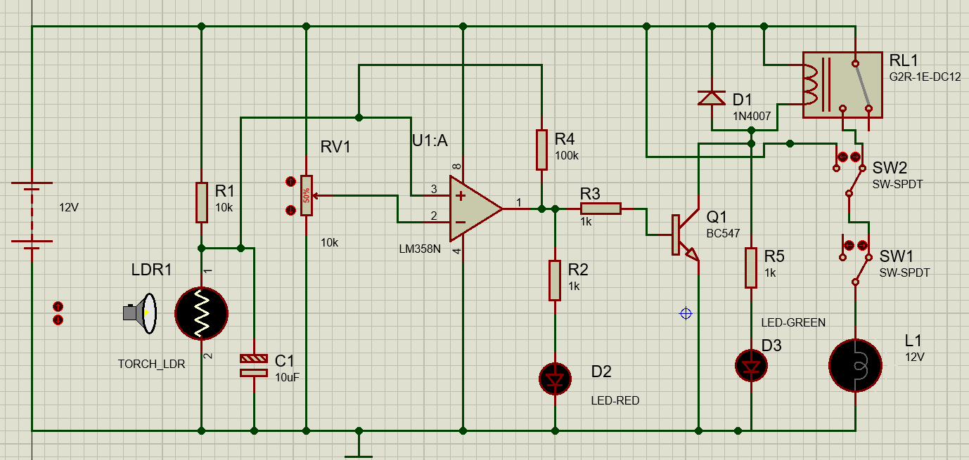
Fig. 1. Complete schematic of the light-activated automatic street light controller (Proteus 8).

4. Component Description and Function
Table II lists every component in the design together with its value and the specific function it performs. The functional descriptions are not generic definitions; each states why that part is present in this circuit and what would fail without it.
Table II. Component list and functional role
Ref. | Device | Value | Function in this circuit
BAT1 | BATTERY | 12 V | Single supply rail for the entire controller and the lamp.
R1 | RES | 10 kΩ | Upper leg of the sensing divider; sets the divider mid-point at the twilight LDR resistance.
LDR1 | TORCH_LDR | — | Light sensor. Resistance rises in darkness, raising the voltage at node A.
C1 | CAP | 10 µF | Low-pass filter at node A; rejects brief optical transients (τ ≈ 48 ms, f(c) ≈ 3.3 Hz).
RV1 | POT-HG | 10 kΩ | Adjustable reference; sets the light level at which the lamp switches. Wiper at 50 % gives 6.0 V.
U1:A | LM358N | — | Open-loop comparator. Compares the sensing voltage against the reference and saturates its output accordingly.
R4 | RES | 100 kΩ | Positive-feedback resistor. Creates the 0.53 V hysteresis band that prevents chatter at the trip point.
R2 | RES | 1 kΩ | Current limiter for D2 (≈ 8.4 mA).
D2 | LED-RED | — | Night indicator. Lit whenever the comparator output is HIGH (sensor reports darkness).
R3 | RES | 1 kΩ | Base resistor for Q1; sets I(B) = 9.74 mA, driving the transistor into hard saturation.
Q1 | BC547 | NPN | Low-side switch. Supplies the ≈ 43 mA of coil current the op-amp cannot source.
RL1 | G2R-1E-DC12 | 12 V coil | Isolates the lamp circuit from the control electronics; its NO contact switches the lamp.
D1 | 1N4007 | — | Freewheeling diode. Clamps the coil's back-EMF spike when Q1 turns off, protecting the transistor.
R5 | RES | 1 kΩ | Current limiter for D3 (≈ 7.8 mA, flowing through the coil).
D3 | LED-GREEN | — | Day indicator. Lit whenever Q1 is off (sensor reports daylight).
SW1 | SW-SPDT | — | Mode selector: relay contact (automatic) or +12 V rail (forced on).
SW2 | SW-SPDT | — | Master cut-off in series with the lamp; opening it forces the lamp off.
L1 | LAMP | 12 V | The street lamp load.

5. Circuit Operation

5.1 Automatic mode
With SW1 selecting the relay contact and SW2 closed, the controller runs autonomously. In daylight the LDR's resistance is low, node A sits near 1 V, the comparator's non-inverting input is below the 6 V reference, and the output saturates near 0 V. Q1 has no base drive, the coil is de-energised, the NO contact is open and the lamp is dark; the collector sits near the rail, so the green LED is lit.
As dusk falls the LDR's resistance rises and node A climbs. When it crosses the upper trip point of 6.32 V the comparator output snaps HIGH to 10.44 V. Positive feedback through R4 immediately lifts node A further, to a measured 8.12 V, which drives the transition to completion and prevents any oscillation at the boundary. Base current flows, Q1 saturates, the coil energises, the NO contact closes and the lamp lights. The red LED lights simultaneously and the green LED extinguishes.
At dawn the process reverses, but not at the same light level: the output cannot return LOW until node A has fallen below 5.79 V, because the feedback is still holding it up. That 0.53 V gap is the hysteresis, and it is what guarantees a single clean transition rather than a burst of switching.
Table III. Automatic-mode operating states
Condition | R(LDR) | U1:A output | Q1 | D2 | D3 | Lamp L1
Daylight | ≈ 1 kΩ | LOW (≈ 0 V) | Off | Off | On | OFF
Darkness | ≈ 100 kΩ | HIGH (10.44 V) | Saturated | On | Off | ON

5.2 Manual override
The two switches give three usable states, summarised in Table IV. Note that in both override states the indicator LEDs continue to report the true sensor decision, because they are tapped upstream of the switches. This is a useful diagnostic property: an operator can see at a glance that the lamp is on only because it has been forced on, and that the sensor itself still believes it is daytime.
Table IV. Override matrix
SW1 | SW2 | Lamp behaviour | Intended use
Relay (auto) | Closed | Follows the sensor | Normal unattended operation.
+12 V (manual) | Closed | Forced ON, sensor ignored | Testing or servicing a lamp during daylight.
Either | Open | Forced OFF, sensor ignored | Isolating a lamp at night for maintenance.

6. Simulation Setup and Results

6.1 Simulation environment
The circuit was captured and simulated in the Proteus 8 Design Suite using interactive (animated) simulation. Ambient light is modelled by the TORCH_LDR component, whose illumination is controlled by an on-screen light source; raising the source's control voltage simulates daylight and lowering it simulates darkness. Real-time voltage probes (RTVPROBE) were placed at the sensing node and at the comparator output to record node voltages during the sweep.

6.2 Electrical rule check
Before any simulation was run, the design was validated with Proteus's Electrical Rule Check. The netlist generated without error and no rule violations were reported (Fig. 7, Appendix A), confirming that there are no shorted nets, floating pins or unconnected power rails in the captured schematic.

6.3 Case A — Daylight, automatic mode
With the light source at maximum intensity and SW1 in the automatic position, the LDR resistance is low, the comparator output is LOW, and the relay remains released. The green LED is lit and both the red LED and the lamp are dark, which matches the predicted daylight row of Table III.
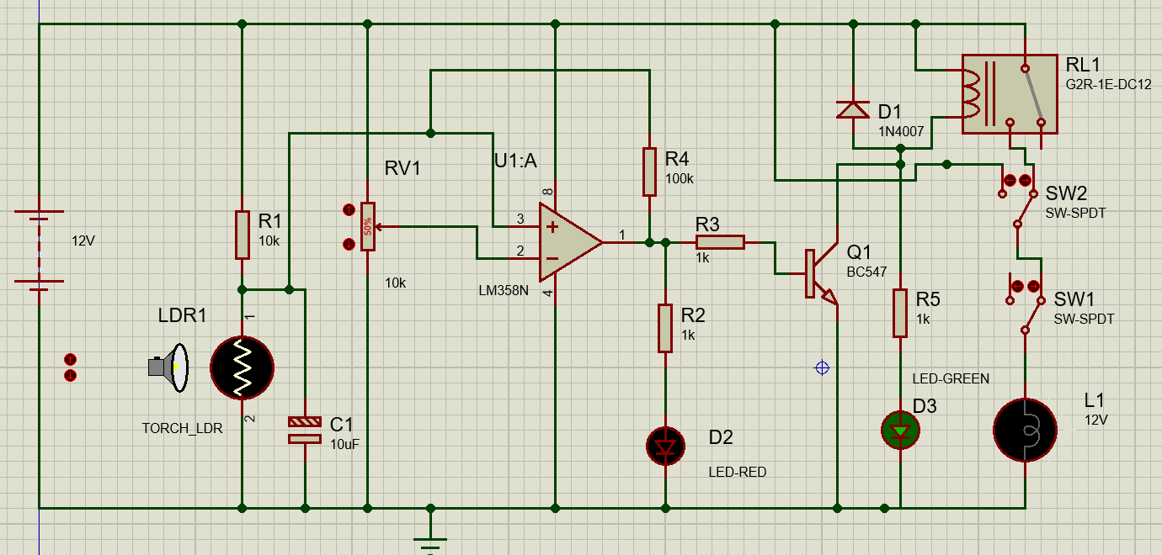
Fig. 2. Case A — daylight, automatic mode: lamp OFF, green (day) LED lit.

6.4 Case B — Darkness, automatic mode
Reducing the light source to zero raises the LDR resistance past the upper trip point. The comparator output snaps HIGH, Q1 saturates, the relay energises and its NO contact closes, and the lamp lights. The red LED is lit and the green LED is extinguished. This is the intended dusk-to-dawn behaviour.
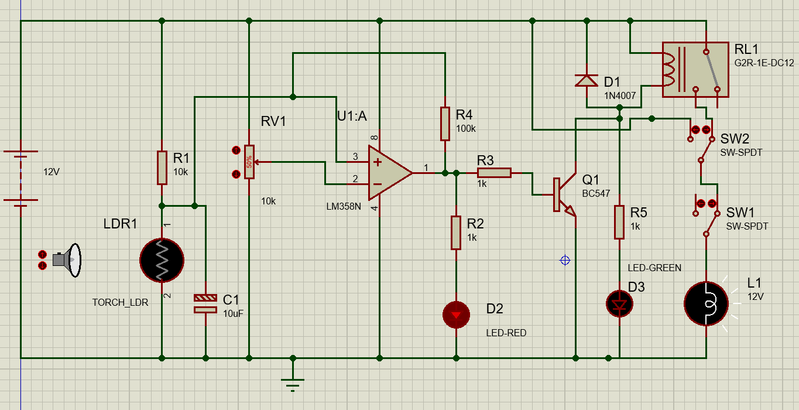
Fig. 3. Case B — darkness, automatic mode: lamp ON, red (night) LED lit.

6.5 Case C — Daylight with forced-on override
With the light source still at maximum intensity, SW1 was moved to the +12 V position. The lamp lights even though the sensor correctly continues to report daylight, as confirmed by the green LED remaining lit. This demonstrates that the override successfully bypasses the relay and the sensing chain.
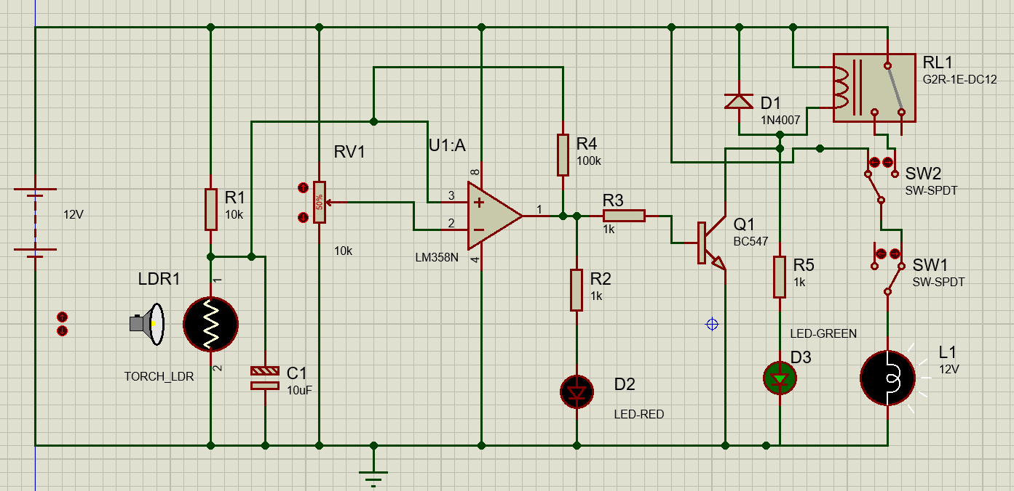
Fig. 4. Case C — daylight with SW1 in the manual position: lamp forced ON while the day indicator remains lit.

6.6 Case D — Darkness with master cut-off
With the light source at zero and SW1 returned to automatic, SW2 was opened. The lamp is extinguished even though the sensor correctly reports darkness, as confirmed by the red LED remaining lit. This demonstrates the force-off capability that a single-switch override cannot provide.
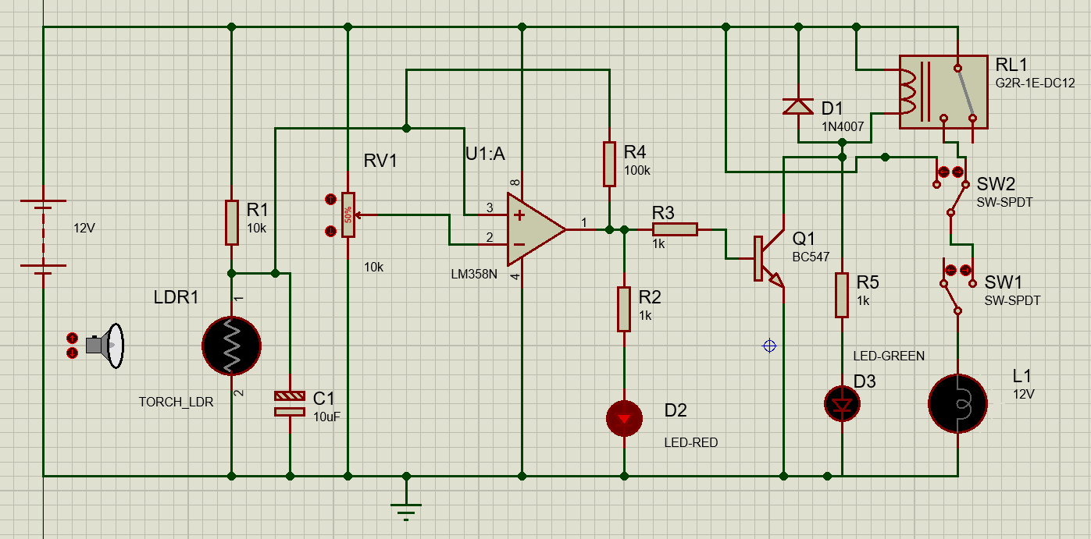
Fig. 5. Case D — darkness with SW2 open: lamp forced OFF while the night indicator remains lit.

6.7 Hysteresis measurement
The terminal voltages of U1:A were recorded immediately after each transition. Table V lists the results. In both states the non-inverting input has been displaced well clear of the 6 V reference by the feedback through R4 — upward by 2.15 V after switching on and downward by 2.13 V after switching off. This displacement is the regenerative action of the Schmitt trigger, and it is what makes a return transition impossible without a substantial change in illumination.
Table V. Measured U1:A terminal voltages after switching
State | V(+IP) | V(−IP) | V(OP) | V+
After switching ON (dark) | 8.119 V | 5.974 V | 10.44 V | 11.95 V
After switching OFF (bright) | 3.871 V | 6.000 V | −11.14 mV | 12.00 V

The measured output levels are the values used in (3), (4) and (6). The close agreement between the two independent estimates of the hysteresis band — 0.53 V from the exact KCL solution and 0.50 V from the small-signal approximation — confirms that the circuit behaves as the design equations predict.

6.8 Summary of results
All four operating states were reproduced exactly as designed, the netlist passed rule checking, and the measured hysteresis agrees with theory to within 6 %. The simulation therefore validates both the topology and the component values chosen in Section 2.

7. Bill of Materials
Fig. 6 reproduces the bill of materials generated directly from the Proteus netlist. It lists eighteen parts across six categories, which agrees with the component list in Table II.
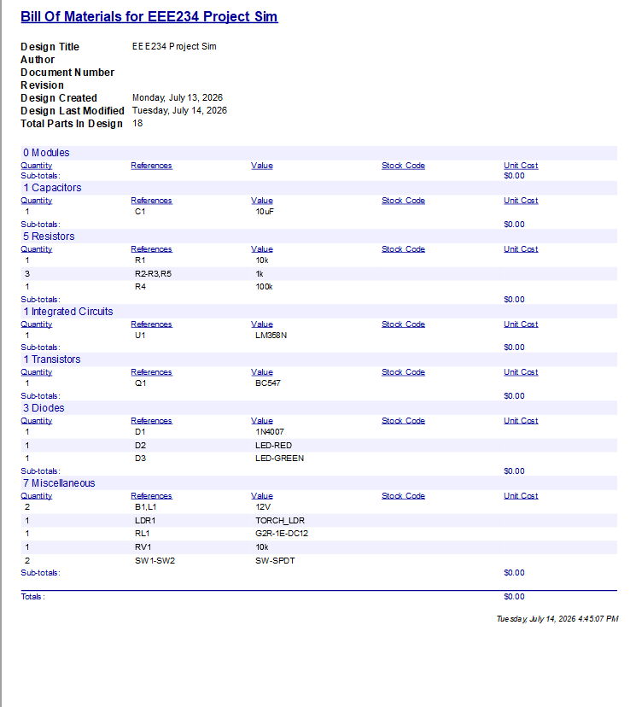
Fig. 6. Bill of materials generated by Proteus 8 from the final netlist.

8. Performance Analysis

8.1 Power budget
Table VI estimates the current drawn by the control electronics in each state, excluding the lamp itself. The relay coil dominates the night-time budget, accounting for roughly two-thirds of the total control current.
Table VI. Estimated control-circuit current (lamp excluded)
Branch | Daylight (lamp off) | Darkness (lamp on)
Sensing divider (R1, LDR1) | 1.09 mA | 0.11 mA
Reference divider (RV1) | 1.20 mA | 1.20 mA
LM358 quiescent | ≈ 0.70 mA | ≈ 0.70 mA
Red LED branch (R2, D2) | — | 8.40 mA
Green LED branch (R5, D3) | 7.80 mA | —
Base drive (R3) | — | 9.74 mA
Relay coil (RL1) | — | 43.0 mA
Total control current | ≈ 10.8 mA | ≈ 63.2 mA
Control power at 12 V | ≈ 0.13 W | ≈ 0.76 W

The lamp's own consumption must be added to the night-time figure and is set by the lamp's rating, P(L) = V² / R(L). For the 12 V lamp model used in simulation this dominates the total draw by an order of magnitude, which is expected: the point of the controller is to ensure that this large load is energised only when it is actually needed.

8.2 Design margins
- Q1 collector current (43 mA) is 43 % of the BC547's 100 mA absolute maximum.
- Forced beta of 4.4 is well below the device's minimum hFE of about 110, guaranteeing saturation across normal parameter spread.
- The green LED's 7.8 mA holding current through the coil is roughly one-fifth of the relay's operating current, safely below the must-operate threshold.
- All sensing-node voltages (1.09 V to 10.91 V) lie within the LM358's single-supply input common-mode range.

9. Additional Feature: Microcontroller-Based Fault Detection
The controller described in Sections 2 to 8 performs its job correctly, but it is silent about its own health. If the lamp burns out, or an indicator LED fails, or the LDR comes loose, the circuit keeps operating on whatever it is told and gives no sign that anything is wrong. In a single installation a person would eventually notice; across a network of thousands of street lights, nobody can inspect each pole by hand. This section describes a fault-detection layer added on top of the existing design, built around an ATmega328P microcontroller, that watches the circuit and reports failures automatically. Everything in the earlier sections remains unchanged — this subsystem is added alongside it, not in place of it.

9.1 Design philosophy
Two principles shaped the whole addition. First, the monitor is a separate observer, not a redesign. The original analogue circuit still runs entirely on its own; if the microcontroller or its program were removed, the street light would keep working exactly as before. The part that watches for faults must never be able to cause one. Second, the monitor only ever reads the circuit, never drives it. Every connection from the circuit to the microcontroller is a high-impedance tap that draws negligible current, so measuring a node cannot disturb it — the same reasoning that lets the op-amp read the sensing divider without loading it.

9.2 Interfacing the microcontroller safely
The ATmega328P runs on 5 V and its input pins tolerate at most 5 V, while the street-light circuit runs on 12 V. Every 12 V node that the microcontroller needs to read is therefore first passed through a resistor voltage divider that scales it into the safe range. A 10 kΩ and 4.7 kΩ pair is used throughout:
V_{ADC} = 12 V × 4.7 kΩ / (10 kΩ + 4.7 kΩ) = 3.84 V (15)
This sits comfortably below the 5 V limit with margin to spare. The microcontroller's program reverses this scaling in software by multiplying each divided reading by the same ratio, so it recovers the true node voltage for its decisions. Small sense voltages — those developed across the current-sensing resistors described below — are already well under 5 V and are read directly, without a divider. The microcontroller is given its own 5 V supply (B2) and shares a common ground with the main circuit, which is essential: a voltage reading is only meaningful relative to a shared reference.
A 16 MHz crystal (X1) with two 22 pF capacitors provides the clock, and a 10 kΩ pull-up holds the reset line inactive — the same supporting circuitry found on any Arduino board, since the ATmega328P is the identical chip used inside the Arduino Uno. This allowed the firmware to be written and compiled in the standard Arduino environment and loaded directly into the chip in simulation.

9.3 How each fault is detected
Lamp monitoring. The lamp is the most important part of the system and the single most likely component to fail, since a filament wears out where a resistor essentially does not. A burnt-out lamp has a distinctive signature: voltage is still being applied to it, but no current flows through it. The monitor watches for exactly this. A small 10 Ω sense resistor (Rsense) is placed in the lamp's return path; current through the lamp develops a measurable voltage across it, so a reading near zero means no current is flowing. Separately, the lamp's supply-side voltage is read through a divider. When supply voltage is present but sense voltage is absent, the lamp has failed:
LAMP_FAULT = ( V_{supply} > 6 V ) AND ( V_{sense} ≤ 0.3 V ) (16)
Because the supply voltage is tapped at the lamp itself — after the manual override switches — this check is automatically correct when the lamp is switched off on purpose: with no voltage reaching the lamp, the first condition is false and no fault is reported. This point is revisited in the override discussion below.
Indicator LED monitoring. The two indicator LEDs are the system's status display — the thing a person glances at to read its state. A dead status light is worse than useless: if the green “day” LED fails, an observer sees nothing lit and wrongly concludes the system is off. The same current-versus-command test used for the lamp is therefore applied to each LED. A small sense resistor in each LED's path reports whether current is flowing, and the node that commands the LED (the comparator output for the red LED, the transistor collector for the green LED) reports whether it is supposed to be lit. An LED commanded on but drawing no current has failed.
Sensor fault detection. The LDR is the system's eye, and a failed sensor is especially deceptive: if it shorts or comes loose, the whole circuit misbehaves — lamp stuck on all day or off all night — yet every other check still looks fine, because the circuit is faithfully obeying a broken sensor. This fault cannot be caught with a current test, because the LDR has no separate “commanded” signal to compare against; it is itself the source of truth. Instead, the monitor checks whether the sensing voltage sits somewhere a real LDR could ever produce. A genuine LDR always has a finite resistance, so the sensing node can approach the supply rails but never quite reach them. A reading pinned hard against ground means the sensor is shorted; a reading pinned hard against the rail means it is disconnected:
SENSOR_SHORTED = ( V_{A} < 0.5 V ) ; SENSOR_OPEN = ( V_{A} > 11.71 V ) (17)
The two cases are reported as distinct messages, since a technician benefits from knowing which failure occurred. The upper threshold of 11.71 V was not assumed but calibrated from the circuit itself: in simulation the sensing node read 11.66 V at genuine full darkness and 11.76 V when the LDR was physically disconnected, so the threshold was placed midway between these two measured values. The narrow gap between them is discussed as a limitation in Section 12.

9.4 Alerting and indication
A buzzer (BUZ1) sounds whenever any fault is active, alerting a maintenance person without their needing to watch the panel. It is driven with an on/off beeping pattern rather than a steady tone, because an intermittent beep is recognised as an alarm where a continuous tone tends to fade into background noise and be ignored.
The buzzer announces that something is wrong; four dedicated indicator LEDs (D4–D7) announce what is wrong — one each for the lamp, the red LED, the green LED, and the sensor. This lets a technician go straight to the correct fault instead of diagnosing from scratch. The mapping of each LED to its fault, and to the driving pin, is given in Table VII.
Table VII. Fault-indicator LED assignment
LED | Driven from | Indicates
D4 | PB2 (pin 14) | Lamp fault — powered but not conducting
D5 | PB3 (pin 15) | Red (night) indicator LED failed
D6 | PB4 (pin 16) | Green (day) indicator LED failed
D7 | PB5 (pin 17) | Sensor fault — shorted or disconnected

9.5 Serial fault log
Alongside the lights and buzzer, the monitor prints readable status messages to a serial terminal, forming a log of the sort a real monitoring installation keeps. Two design choices make this log useful rather than noisy. First, messages are event-based: a line is printed only when a fault begins or clears, not repeatedly while it persists, so the log records transitions like “FAULT: Lamp not conducting” and later “CLEARED: Lamp fault resolved,” each with a timestamp. Second, a short “heartbeat” line is printed every ten seconds even when nothing is wrong. This is deliberate: without it, a silent terminal would be ambiguous between “all is well” and “the monitor itself has crashed.” The heartbeat removes that ambiguity and doubles as a periodic snapshot of every measured voltage.

9.6 Override-aware operation
The manual override switches from the base design pose a subtle problem for any fault monitor: when an operator deliberately switches the lamp off, a naive detector would see “no lamp current” and wrongly raise a lamp fault. A monitor that cries wolf during normal operation is quickly ignored, so the design must distinguish “operator turned it off” from “bulb burnt out.”
For the lamp check this is already handled, as noted in 9.3: because supply voltage is measured after the override switches, an intentional shut-off removes the supply voltage and the fault condition is simply never met. Beyond that, the monitor also actively recognises override activity, without needing to read the switch positions directly — which is not reliably possible, since one throw of the mode switch tracks the variable relay signal. Instead it compares what the sensor logic wants (the transistor-collector voltage) against what is actually happening at the lamp (the supply voltage). In normal automatic operation these always agree. A disagreement can only mean an operator has intervened: lamp powered while the sensor reads daylight indicates a forced-on override; lamp unpowered while the sensor reads darkness indicates a forced-off override or cut-off. These are logged as informational “MODE” messages and deliberately do not trigger the buzzer or fault LEDs, because an intentional override is not a malfunction.

9.7 Complete circuit with fault-detection subsystem
Fig. 7 shows the full circuit with the monitoring subsystem added. The original street-light controller occupies the upper portion and is unchanged; the microcontroller, its supporting components, the sense resistors, the buzzer, and the four fault-indicator LEDs form the lower portion. Fig. 8 is a closer view of the microcontroller section for legibility.
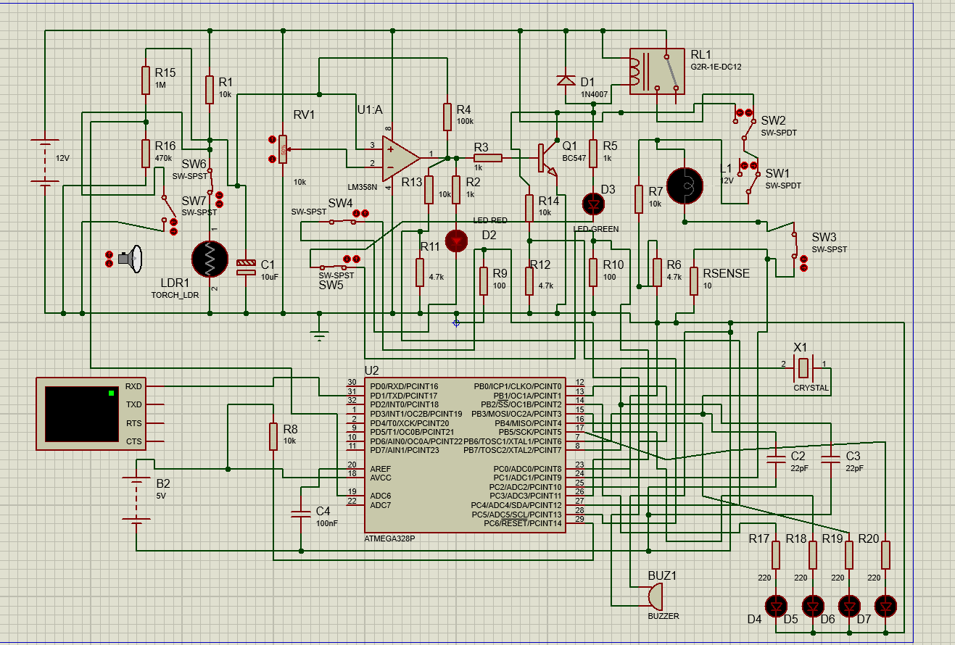
Fig. 7. Complete circuit: original controller (top) with the added ATmega328P fault-detection subsystem (bottom).
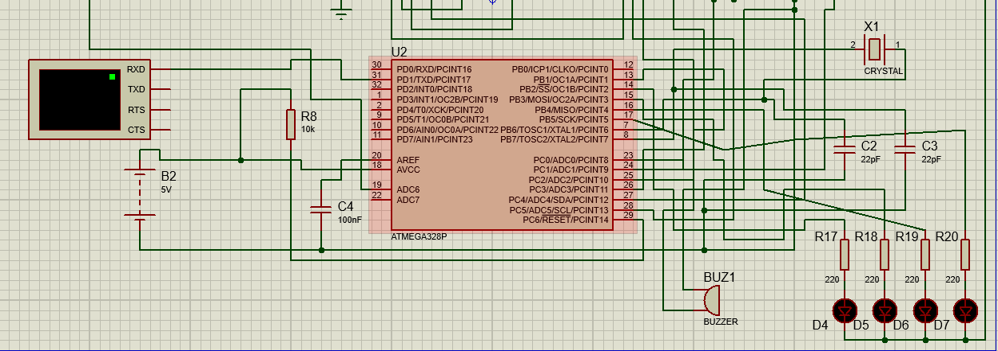
Fig. 8. Detail of the monitoring subsystem: ATmega328P, 16 MHz clock, serial terminal, buzzer, and the four fault LEDs.

9.8 Simulation and verification
Every fault type was injected in simulation using temporary switches that reproduce each failure — opening a switch in the lamp path mimics a burnt filament, opening a switch in an LED path mimics a failed indicator, and switches across the LDR reproduce the open and shorted sensor. In each case the serial log, the buzzer, and the corresponding fault LED were observed. The results below are the actual terminal output captured during these tests; the bracketed figures are millisecond timestamps from the microcontroller.
Normal operation. With no fault present, the log stays quiet apart from the ten-second heartbeat, which also confirms the healthy baseline voltages (Fig. 9).
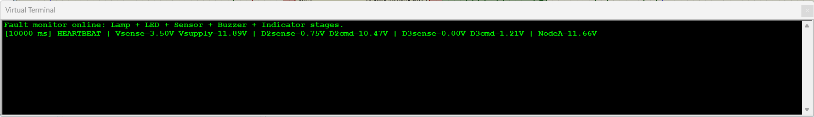
Fig. 9. Normal operation: only the periodic heartbeat prints, showing healthy readings.
Lamp fault. Injecting an open lamp while the lamp should be lit produces an immediate fault message; restoring it produces the matching cleared message. The heartbeats on either side confirm the supply-present / no-current signature during the fault and the return of current afterwards (Fig. 10).
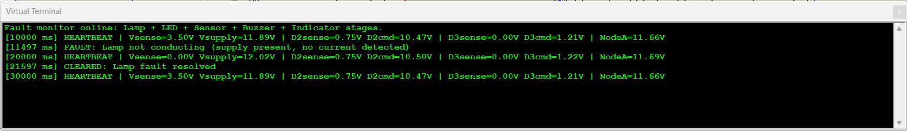
Fig. 10. Lamp fault detected and cleared, bracketed by heartbeat snapshots.
Indicator LED faults. Failing the red LED while it is commanded on, and the green LED while it is commanded on, each produce the correct dedicated message and clear correctly (Figs. 11 and 12).
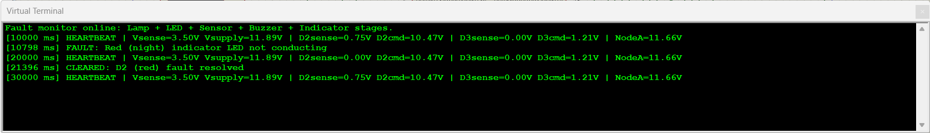
Fig. 11. Red (night) indicator LED fault detected and cleared.
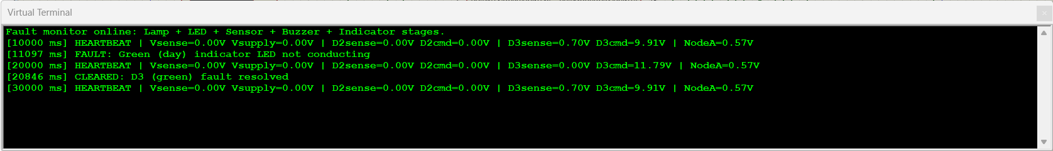
Fig. 12. Green (day) indicator LED fault detected and cleared.
Sensor faults. Disconnecting the LDR drives the sensing node above the calibrated threshold and is reported as a disconnection; shorting it drives the node to ground and is reported as a short. Fig. 13 shows both cases, each with its own message, captured in one continuous run.
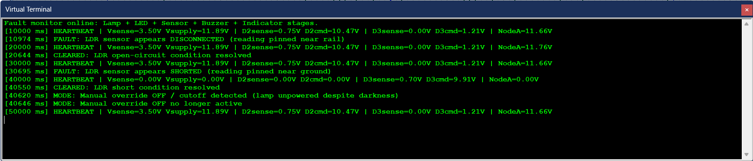
Fig. 13. Both sensor failure modes — disconnected and shorted — detected and cleared as distinct events.
Manual override recognition. Forcing the lamp on during daylight, and forcing it off during darkness, are each correctly identified as override activity and logged as MODE events without raising an alarm (Figs. 14 and 15).
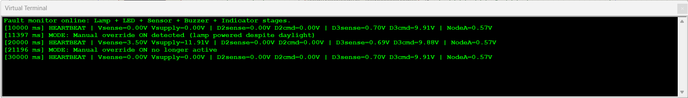
Fig. 14. Manual forced-on override recognised during daylight; logged as a MODE event, no alarm raised.
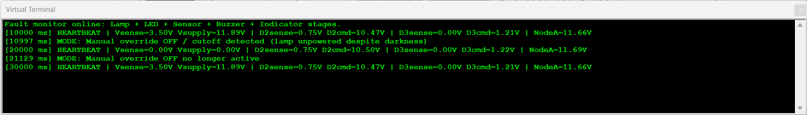
Fig. 15. Manual forced-off override recognised during darkness; logged as a MODE event, no alarm raised.
Across all cases the subsystem behaved as designed: every genuine fault produced its message, its LED, and the buzzer; every intentional override was logged without an alarm; and every condition cleared correctly when resolved. Table VIII summarises the verification.
Table VIII. Fault-detection verification summary
Condition injected | Expected response | Result
Lamp open (powered, no current) | LAMP fault + D4 + buzzer | Pass
Red LED failed while commanded on | D2 fault + D5 + buzzer | Pass
Green LED failed while commanded on | D3 fault + D6 + buzzer | Pass
LDR disconnected | SENSOR (open) + D7 + buzzer | Pass
LDR shorted | SENSOR (short) + D7 + buzzer | Pass
Forced ON in daylight | MODE log only, no alarm | Pass
Forced OFF in darkness | MODE log only, no alarm | Pass
All faults cleared | CLEARED messages, all off | Pass

9.9 Bill of materials — added subsystem
Table IX lists the components added for the fault-detection subsystem. These are additional to the original bill of materials in Section 7; the complete Proteus-generated bill for the combined design is reproduced in Appendix B.
Table IX. Added components for the fault-detection subsystem
Ref. | Device | Value | Function
U2 | ATMEGA328P | — | Fault-monitoring microcontroller.
X1 | CRYSTAL | 16 MHz | Clock source for U2.
C2, C3 | CAP | 22 pF | Crystal loading capacitors.
C4 | CAP | 100 nF | Decoupling for the reference pin.
B2 | BATTERY | 5 V | Separate logic supply for U2.
R8 | RES | 10 kΩ | Reset pull-up for U2.
Rsense | RES | 10 Ω | Lamp current-sense resistor.
R9, R10 | RES | 100 Ω | Indicator-LED current-sense resistors.
R15, R16 | RES | 1 M / 470 k | High-impedance divider for the sensing-node tap.
R17–R20 | RES | 220 Ω | Current limiters for the four fault LEDs.
D4–D7 | LED | — | Per-fault indicator LEDs (see Table VII).
BUZ1 | BUZZER | — | Audible fault alarm.
SW4, SW5 | SW-SPST | — | Test switches to inject indicator-LED faults.
SW6, SW7 | SW-SPST | — | Test switches to inject sensor open/short faults.

Note that SW4–SW7, together with the sense resistors' associated dividers, are present to demonstrate and exercise the fault conditions in simulation; a deployed unit would monitor the same nodes without the fault-injection switches. Additional divider resistors feeding the microcontroller's inputs are omitted from the table for brevity but follow the 10 kΩ / 4.7 kΩ pattern of (15).

10. Hardware Implementation
This section is reserved for the hardware implementation and will be completed after the physical prototype has been built and tested. The subsection structure below is provided so that the results can be inserted directly into the finished report.

9.1 Component procurement and substitutions
[List the parts actually purchased. Record any substitutions made against the Proteus bill of materials in Section 7 — for example, the exact LDR part number used in place of the idealised TORCH_LDR model, the measured coil resistance of the relay actually obtained, and any change in the lamp rating. State the reason for each substitution.]

9.2 Breadboard prototype
[Insert a photograph of the assembled breadboard. Describe the build order used — supply and ground rails first, then the sensing divider, then the comparator, then the driver and relay, then the indicators and override switches — and note any wiring difficulties encountered.]
[Fig. 8. Breadboard prototype of the controller.]

9.3 Threshold calibration
[Describe how RV1 was calibrated on the physical build. Record the wiper position and the measured reference voltage, and state the illuminance (in lux, if a meter is available) or the time of day at which the lamp switched. Explain any difference from the 50 % / 6.0 V setting used in simulation, which will arise because a real LDR's resistance curve differs from the idealised Proteus model.]

9.4 Measured results
[Complete the table below with values measured on the hardware using a multimeter or oscilloscope, and compare each against the simulated value from Sections 6 and 8.]
Table VII. Simulated versus measured results
Quantity | Simulated | Measured | Deviation
V(A) in bright light | ≈ 1.09 V
V(A) in darkness | ≈ 10.91 V
Reference voltage V(−IP) | 6.00 V
Comparator output, HIGH | 10.44 V
Comparator output, LOW | ≈ 0 V
Upper trip point | 6.32 V
Lower trip point | 5.79 V
Hysteresis band ΔV | 0.53 V
Relay coil current | ≈ 43 mA
Control current, day | ≈ 10.8 mA
Control current, night | ≈ 63.2 mA

9.5 Functional verification
[Confirm on hardware each of the four cases verified in simulation: (A) daylight in automatic mode, lamp off; (B) darkness in automatic mode, lamp on; (C) forced-on override in daylight; (D) master cut-off in darkness. Include a photograph of the lamp in the on and off states.]

9.6 Discussion of deviations
[Account for any differences between the simulated and measured results. Likely sources include: LDR manufacturing tolerance and its non-linear resistance-illuminance curve; resistor tolerance (typically ±5 %); the actual relay coil resistance; the LM358's real output saturation voltage under load, which will fall short of the rail by more than the simulation predicts; and ambient light leakage onto the sensor.]

11. Discussion and Limitations
The simulation validates the design, but several limitations should be stated plainly. The TORCH_LDR is an idealised Proteus model; its resistance-illuminance relationship is not that of any specific real device, so the numerical trip points derived here will shift on hardware and RV1 will need recalibration. The 12 V lamp used as the load stands in for what would, in a real installation, be a mains-voltage fixture; the relay topology is chosen precisely so that this substitution changes nothing on the control side, but the contact rating and creepage requirements of the physical relay would need to be checked against the real lamp.
The filtering action of C1 could not be demonstrated interactively, because a manually operated light-source slider moves far more slowly than the 48 ms time constant it is meant to reject. The filter's presence is justified analytically in Section 2.5, but a transient graph driven by an injected pulse would be required to demonstrate it directly.
Finally, the relay is the weakest element of the design in reliability terms. It is the only moving part, it will wear mechanically over tens of thousands of operations, and it draws 43 mA continuously whenever the lamp is lit — more than the entire rest of the control circuit combined.
The fault-detection subsystem of Section 9 carries its own limitation, in the sensor check. The idealised LDR's dark resistance is so much larger than the 10 kΩ upper divider resistor that the sensing node already sits close to the supply rail in genuine darkness, leaving only about a 0.10 V gap between “truly dark” (11.66 V) and “disconnected” (11.76 V). In this deterministic simulation, with no electrical noise, a threshold placed midway separates the two reliably; on real hardware, where thermal drift and component tolerance are present, so narrow a margin could not be trusted. A robust hardware version of the sensor check would need either a different sensing arrangement that widens this gap, or per-unit calibration against the specific LDR's measured dark resistance. This is a genuine constraint of the method, not a defect in the implementation, and it is the analogue of the same LDR-tolerance caveat that affects the base circuit's trip point.

12. Future Work
- Transient verification of the input filter: inject a pulse into the sensing node through a series resistor and plot the raw pulse against the filtered node voltage on an analogue graph, to demonstrate the 3.3 Hz roll-off directly.
- Turn-on delay stage: use the unused second amplifier of the LM358 (U1:B) with a slow RC charging network to require darkness to persist for two to three seconds before the lamp switches, giving immunity to sustained-but-brief events that the 48 ms filter passes.
- Solid-state switching: replace the relay with a logic-level MOSFET. This would eliminate the mechanical wear and the 43 mA coil current, at the cost of losing galvanic isolation and requiring a heatsink at higher load currents. For a mains lamp a triac with an opto-isolated gate driver would preserve isolation.
- Supply protection: add a series reverse-polarity diode and a fuse at the battery input.
- Field calibration against a lux meter, so that the trip point can be specified in lux rather than as a potentiometer position.
- Extending the fault-detection subsystem: widening the sensor-check margin with a dedicated reference divider, logging faults to non-volatile memory with real timestamps, and reporting faults over a wireless link so a central office is notified without a site visit — the natural next step for a networked deployment.

13. Conclusion
A light-activated automatic street light controller was designed, analysed and simulated in Proteus 8. The design uses an LDR divider and one half of an LM358 as a comparator, with the switching threshold set by a potentiometer. Three refinements raise it above a minimal comparator circuit: positive feedback through a 100 kΩ resistor produces a 0.53 V hysteresis band that prevents chatter at dusk; a 10 µF capacitor at the sensing node gives a 3.3 Hz roll-off that rejects brief optical disturbances; and a two-switch arrangement provides a genuine three-state manual override capable of forcing the lamp both on and off independently of the sensor. The output stage drives a relay through a saturated BC547 with a forced beta of 4.4 and a properly oriented freewheeling diode, and the lamp is taken from the normally-open contact so that it lights only in darkness.
The netlist passed Electrical Rule Check without error, all four operating states were verified in simulation, and the measured hysteresis band agreed with the design equations to within 6 %.
Building on this, a microcontroller-based fault-detection subsystem was added (Section 9) that monitors the circuit's own health without altering its operation. Using an ATmega328P as an independent observer, it detects a failed lamp, a failed indicator LED, and an open or shorted sensor, alerts through a buzzer and dedicated per-fault LEDs, keeps a timestamped serial log, and distinguishes genuine faults from intentional manual overrides. All fault types were injected and correctly identified in simulation. Together, the base controller and the monitoring layer form a design that not only switches a street light automatically but also reports when it can no longer do so — the capability a real networked deployment requires. Both parts are validated in simulation and ready for the hardware implementation reported in Section 10.

References
[1] A. S. Sedra and K. C. Smith, Microelectronic Circuits, 7th ed. New York, NY, USA: Oxford Univ. Press, 2015.
[2] R. L. Boylestad and L. Nashelsky, Electronic Devices and Circuit Theory, 11th ed. Boston, MA, USA: Pearson, 2013.
[3] P. Horowitz and W. Hill, The Art of Electronics, 3rd ed. Cambridge, U.K.: Cambridge Univ. Press, 2015.
[4] Texas Instruments, “LM158, LM258, LM358, LM2904 dual operational amplifiers,” LM358 datasheet.
[5] ON Semiconductor, “BC546/BC547/BC548 general-purpose NPN transistors,” BC547 datasheet.
[6] Vishay Semiconductors, “1N4001 through 1N4007 general-purpose plastic rectifiers,” datasheet.
[7] Omron Electronic Components, “G2R series PCB power relay,” datasheet.
[8] Labcenter Electronics, Proteus Design Suite 8: Schematic Capture and Simulation User Manual.

Appendix A — Electrical Rule Check (base controller)
The Electrical Rule Check was run on the base controller netlist of Sections 2 to 8. No errors were reported, confirming that every pin is connected, no nets are shorted, and the power rails are correctly defined.
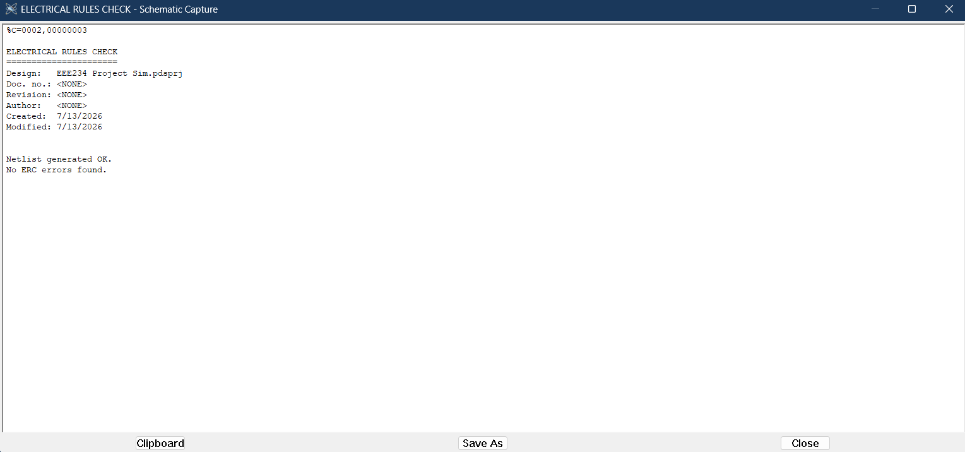
Fig. 16. Electrical Rule Check for the base controller: netlist generated, no ERC errors found.

Appendix B — Electrical Rule Check (with fault-detection subsystem)
The Electrical Rule Check was re-run on the complete design including the fault-detection subsystem. The netlist generated successfully. Two “undriven input” notices remain and are expected and harmless: ADC7 is an unused spare analogue input on the microcontroller, and CTS is a hardware-flow-control pin of the virtual serial terminal that is not needed for one-way logging. Neither affects the circuit's operation; every pin that carries a signal in the design is correctly driven.
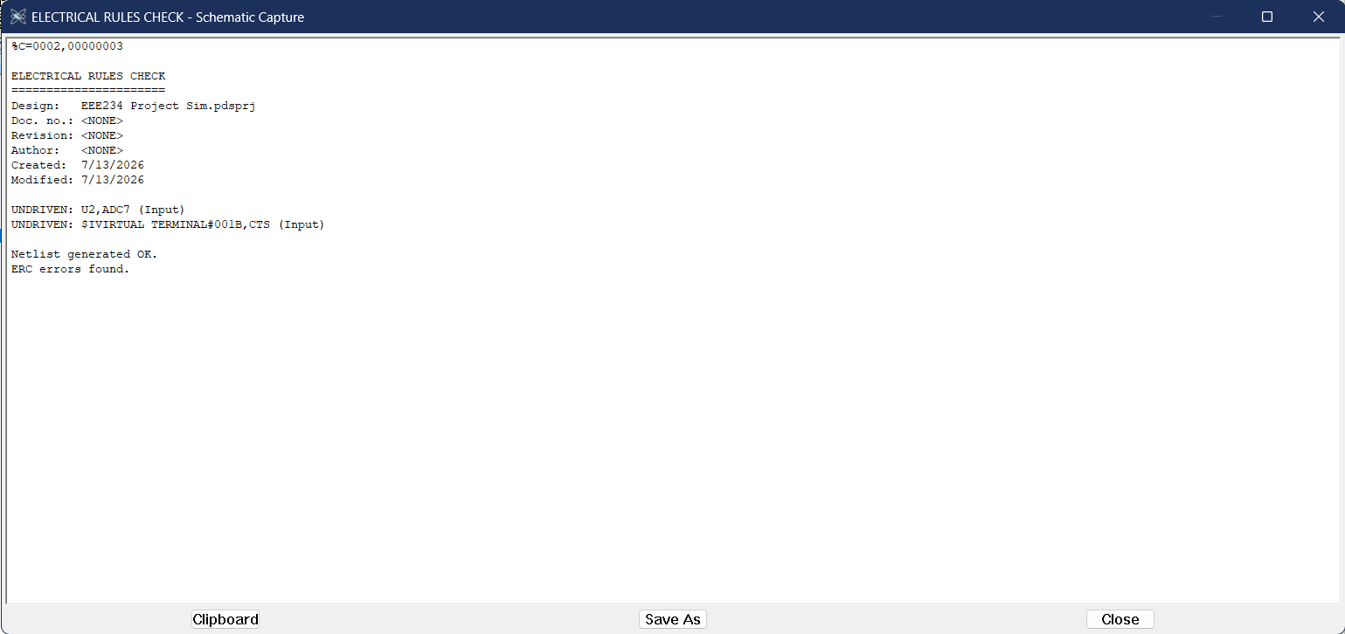
Fig. 17. Electrical Rule Check for the complete design; the only notices are two intentionally unused input pins.

Appendix C — Complete Bill of Materials (Proteus-generated)
The following bill of materials was generated by Proteus from the netlist of the complete design, covering both the base controller and the fault-detection subsystem.
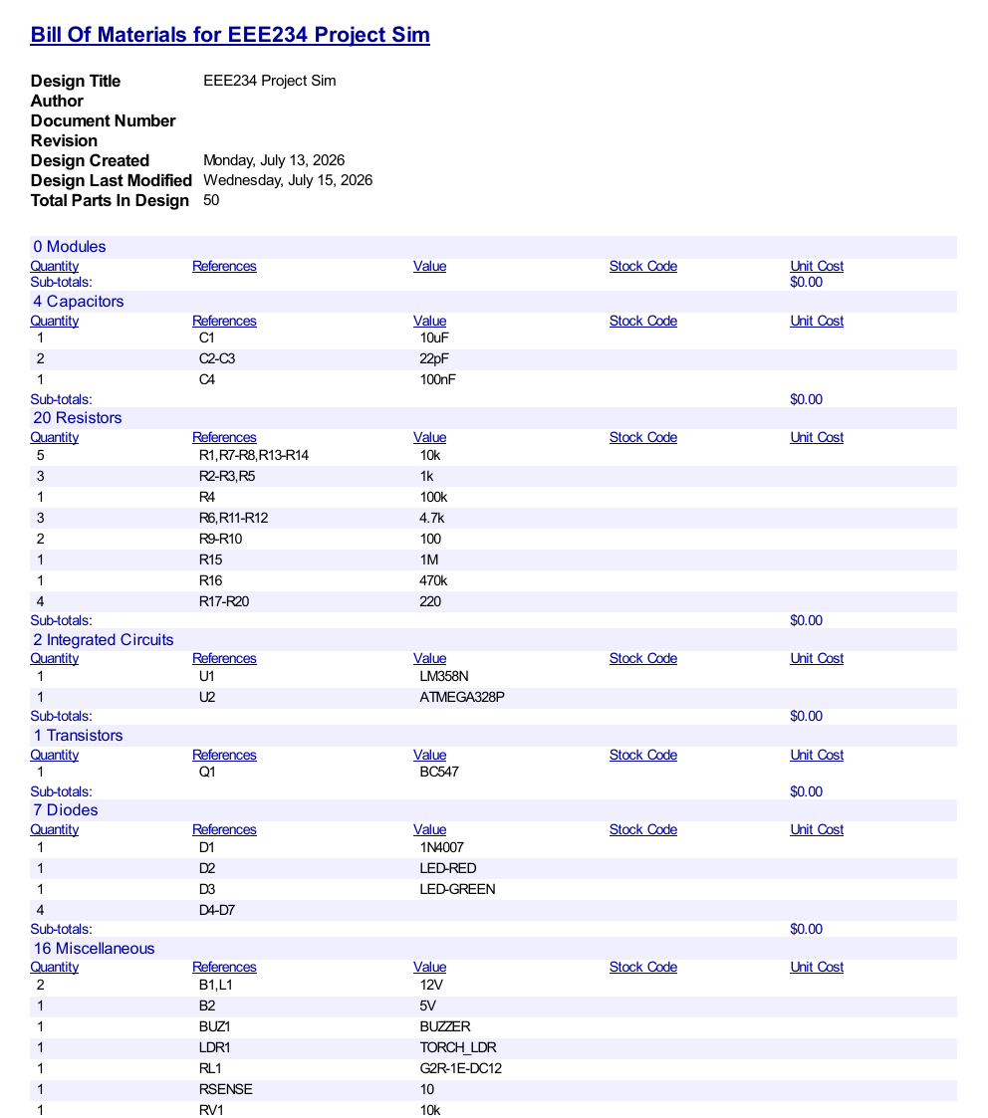

Appendix D — Fault-Detection Firmware Listing
The following is the complete Arduino/ATmega328P firmware for the fault-detection subsystem described in Section 9, as compiled and loaded into the simulation.
/*
EEE234 Project 5 - Street Light Fault Monitor
================================================
Stage 1: Lamp Monitoring
Stage 2: LED (status indicator) Monitoring
Stage 3: Sensor (LDR) Fault Detection
Stage 4: Buzzer Alarm

Stage 1 detects a burnt-out / open-circuit lamp: supply voltage
is present at L1, but no current is actually flowing.

Stage 2 applies the identical idea to D2 (red, night indicator)
and D3 (green, day indicator): each LED should only be dark when
it is NOT commanded on. If it is commanded on but no current
flows through it, that LED itself has failed.

Stage 3 is different: the LDR has no independent second signal to
compare against, so instead we check whether node A sits at a
voltage a genuine LDR could ever physically produce. A real LDR's
resistance is always finite, so node A can approach the rails but
never quite touch them. A reading pinned right at an extreme means
the sensor itself has failed open or shorted, not that it is truly
reporting an extreme light level.

Stage 4 sounds an audible alarm whenever any fault is active, so a
maintenance person is alerted without needing to watch the panel.
The buzzer beeps on/off rather than holding a continuous tone -
an intermittent beep reads as "alarm" to a human ear, where a
steady tone tends to fade into background noise and gets ignored.

Stage 5 gives each fault type its own physical LED. The buzzer and
pin 8 tell a person THAT something is wrong; these four LEDs tell
them WHAT, so they can go straight to the right fix instead of
reading the serial log to diagnose from scratch.

Stage 6 replaces the raw per-cycle voltage dump as the primary
output with proper event-based log messages: a line is printed
only when a fault STARTS or CLEARS, not five times a second
regardless of change - this is how real monitoring logs behave.
The sensor fault is also split into two distinct messages here
(shorted vs disconnected), since the two failure modes have
different voltage signatures and a technician benefits from
knowing which one actually happened. A slow HEARTBEAT line still
prints every 10 seconds - not for calibration, but so silence on
the terminal can never be mistaken for the monitor itself having
crashed or frozen. True silence would be ambiguous between "all
clear" and "no signal"; a heartbeat removes that ambiguity.

Stage 7 detects manual override activity WITHOUT reading SW1/SW2
directly (their positions are not reliably distinguishable from
voltage alone, since one throw of SW1 tracks a variable relay
signal). Instead it compares vSupply (what IS happening at the
lamp) against vD3Cmd (what the sensor logic WANTS to happen, via
Q1's collector). In normal Auto operation these always move
together; any mismatch can only be explained by an operator
forcing the lamp via SW1/SW2. This needs no new hardware - both
signals are already sampled every loop. MODE lines are logged the
same way as faults, but never touch the buzzer or fault LEDs,
since an intentional override is not an error condition.

Hardware:
A0 (ADC0) = voltage across Rsense (10 ohm), lamp current sense.
A1 (ADC1) = L1 supply voltage, via 10k/4.7k divider.
A2 (ADC2) = voltage across R9 (100 ohm), D2 current sense.
A3 (ADC3) = voltage across R10 (100 ohm), D3 current sense.
A4 (ADC4) = op-amp pin 1 voltage, via 10k/4.7k divider.
(D2's commanded state - HIGH means D2 should be lit)
A5 (ADC5) = Q1 collector voltage, via 10k/4.7k divider.
(D3's commanded state - HIGH means D3 should be lit)
A6 (ADC6) = node A voltage (R1/LDR1 junction), via 10k/4.7k divider.
Pin 8 = MASTER fault LED (HIGH = any fault, any type).
Pin 9 = BUZZER output. Beeps on/off every 300ms while any
fault is active; silent otherwise.
Pin 10 = LAMP fault LED.
Pin 11 = D2 (red LED) fault LED.
Pin 12 = D3 (green LED) fault LED.
Pin 13 = SENSOR fault LED.
Pin 1(TX) = event log + throttled diagnostics, Virtual Terminal at 9600 baud.

Fault logic:
LAMP_FAULT : supply present (>6V actual) AND lamp current NOT
flowing (<0.30V at Rsense).
D2_FAULT : pin1 commanded HIGH (>6V actual) AND D2 current NOT
flowing (<0.30V at R9).
D3_FAULT : Q1 collector commanded HIGH (>6V actual) AND D3
current NOT flowing (<0.30V at R10).
SENSOR_SHORTED : node A below 0.5V.
SENSOR_OPEN : node A above 11.71V.
(SENSOR_FAULT = SENSOR_SHORTED OR SENSOR_OPEN, both outside what
a real LDR divider can ever produce.)
*/

const int PIN_SENSE = A0; // lamp current sense
const int PIN_SUPPLY = A1; // lamp supply (divided)
const int PIN_D2_SENSE = A2; // D2 current sense
const int PIN_D3_SENSE = A3; // D3 current sense
const int PIN_D2_CMD = A4; // pin 1 / D2 commanded state (divided)
const int PIN_D3_CMD = A5; // Q1 collector / D3 commanded state (divided)
const int PIN_NODE_A = A6; // node A / LDR sensing voltage (divided)
const int PIN_FAULT = 8; // master any-fault LED
const int PIN_BUZZER = 9; // buzzer output
const int PIN_FAULT_LAMP = 10; // lamp fault LED
const int PIN_FAULT_D2 = 11; // D2 fault LED
const int PIN_FAULT_D3 = 12; // D3 fault LED
const int PIN_FAULT_SENSOR = 13; // sensor fault LED

const float VREF = 5.0;
const float ADC_MAX = 1023.0;
const float DIVIDER_GAIN = (10.0 + 4.7) / 4.7; // undoes the 10k/4.7k divider

const float PRESENT_V = 6.0; // actual volts, above = "should be on"
const float CURRENT_FLOW_V = 0.30; // sense-resistor volts, above = current flowing
const float SENSOR_LOW_V = 0.5; // node A below this => LDR likely shorted
const float SENSOR_HIGH_V = 11.71; // node A above this => LDR likely disconnected
// Calibrated from real simulation data: this
// specific LDR's true-dark reading measured
// 11.66V, disconnected measured 11.76V. The
// narrow 0.10V gap is a genuine characteristic
// of this LDR's high dark-state resistance
// relative to R1, not a design error - see
// report Section 11 for discussion.

const unsigned long BEEP_INTERVAL_MS = 300; // buzzer toggle period while faulted
unsigned long lastBeepToggle = 0;
bool buzzerState = false;

const unsigned long HEARTBEAT_INTERVAL_MS = 10000; // "still alive" print period
unsigned long lastHeartbeat = 0;

// Previous-cycle fault states, used to detect START/CLEAR transitions
bool prevLampFault = false;
bool prevD2Fault = false;
bool prevD3Fault = false;
bool prevSensorShorted = false;
bool prevSensorOpen = false;
bool prevOverrideOn = false;
bool prevOverrideOff = false;

void setup() {
pinMode(PIN_FAULT, OUTPUT);
pinMode(PIN_BUZZER, OUTPUT);
pinMode(PIN_FAULT_LAMP, OUTPUT);
pinMode(PIN_FAULT_D2, OUTPUT);
pinMode(PIN_FAULT_D3, OUTPUT);
pinMode(PIN_FAULT_SENSOR, OUTPUT);
Serial.begin(9600);

// Let the analog circuit and ADC settle before trusting any reading.
// Right at power-on, C1/C2/C3 haven't finished charging and the ADC's
// first few conversions are known to be unreliable on AVR chips - this
// is what caused spurious faults at t=8ms during testing. Discarding
// early readings and waiting briefly avoids logging false events.
delay(500);
for (int i = 0; i < 8; i++) {
analogRead(PIN_SENSE);
analogRead(PIN_SUPPLY);
analogRead(PIN_D2_SENSE);
analogRead(PIN_D3_SENSE);
analogRead(PIN_D2_CMD);
analogRead(PIN_D3_CMD);
analogRead(PIN_NODE_A);
}

Serial.println(F("Fault monitor online: Lamp + LED + Sensor + Buzzer + Indicator stages."));
}

void loop() {
float vSense = analogRead(PIN_SENSE) * (VREF / ADC_MAX);
float vSupply = analogRead(PIN_SUPPLY) * (VREF / ADC_MAX) * DIVIDER_GAIN;
float vD2Sense = analogRead(PIN_D2_SENSE) * (VREF / ADC_MAX);
float vD3Sense = analogRead(PIN_D3_SENSE) * (VREF / ADC_MAX);
float vD2Cmd = analogRead(PIN_D2_CMD) * (VREF / ADC_MAX) * DIVIDER_GAIN;
float vD3Cmd = analogRead(PIN_D3_CMD) * (VREF / ADC_MAX) * DIVIDER_GAIN;
float vNodeA = analogRead(PIN_NODE_A) * (VREF / ADC_MAX) * DIVIDER_GAIN;

bool lampFault = (vSupply > PRESENT_V) && (vSense <= CURRENT_FLOW_V);
bool d2Fault = (vD2Cmd > PRESENT_V) && (vD2Sense <= CURRENT_FLOW_V);
bool d3Fault = (vD3Cmd > PRESENT_V) && (vD3Sense <= CURRENT_FLOW_V);
bool sensorShorted = (vNodeA < SENSOR_LOW_V);
bool sensorOpen = (vNodeA > SENSOR_HIGH_V);
bool sensorFault = sensorShorted || sensorOpen;

bool anyFault = lampFault || d2Fault || d3Fault || sensorFault;
digitalWrite(PIN_FAULT, anyFault ? HIGH : LOW);
digitalWrite(PIN_FAULT_LAMP, lampFault ? HIGH : LOW);
digitalWrite(PIN_FAULT_D2, d2Fault ? HIGH : LOW);
digitalWrite(PIN_FAULT_D3, d3Fault ? HIGH : LOW);
digitalWrite(PIN_FAULT_SENSOR, sensorFault ? HIGH : LOW);

if (anyFault) {
if (millis() - lastBeepToggle >= BEEP_INTERVAL_MS) {
buzzerState = !buzzerState;
lastBeepToggle = millis();
}
digitalWrite(PIN_BUZZER, buzzerState ? HIGH : LOW);
} else {
digitalWrite(PIN_BUZZER, LOW);
buzzerState = false;
}

// ---- Event-based log: print only on state CHANGE, not every cycle ----
logTransition(lampFault, prevLampFault,
F("FAULT: Lamp not conducting (supply present, no current detected)"),
F("CLEARED: Lamp fault resolved"));

logTransition(d2Fault, prevD2Fault,
F("FAULT: Red (night) indicator LED not conducting"),
F("CLEARED: D2 (red) fault resolved"));

logTransition(d3Fault, prevD3Fault,
F("FAULT: Green (day) indicator LED not conducting"),
F("CLEARED: D3 (green) fault resolved"));

logTransition(sensorShorted, prevSensorShorted,
F("FAULT: LDR sensor appears SHORTED (reading pinned near ground)"),
F("CLEARED: LDR short condition resolved"));

logTransition(sensorOpen, prevSensorOpen,
F("FAULT: LDR sensor appears DISCONNECTED (reading pinned near rail)"),
F("CLEARED: LDR open-circuit condition resolved"));

// ---- Override mode detection: mismatch between "should" and "is" ----
// Uses only vSupply and vD3Cmd, both already sampled above - no new
// wiring. In Auto mode these two always move together (dark -> relay
// energized -> vSupply high; bright -> relay off -> vSupply low).
// Override shows up as a mismatch between them.
bool overrideForcedOn = (vSupply > PRESENT_V) && (vD3Cmd > PRESENT_V);
bool overrideForcedOff = (vSupply <= CURRENT_FLOW_V) && (vD3Cmd <= PRESENT_V);

logTransition(overrideForcedOn, prevOverrideOn,
F("MODE: Manual override ON detected (lamp powered despite daylight)"),
F("MODE: Manual override ON no longer active"));

logTransition(overrideForcedOff, prevOverrideOff,
F("MODE: Manual override OFF / cutoff detected (lamp unpowered despite darkness)"),
F("MODE: Manual override OFF no longer active"));

prevOverrideOn = overrideForcedOn;
prevOverrideOff = overrideForcedOff;

prevLampFault = lampFault;
prevD2Fault = d2Fault;
prevD3Fault = d3Fault;
prevSensorShorted = sensorShorted;
prevSensorOpen = sensorOpen;

// ---- Heartbeat: proves the monitor is alive, once every 20s ----
if (millis() - lastHeartbeat >= HEARTBEAT_INTERVAL_MS) {
lastHeartbeat = millis();

Serial.print(F("[")); Serial.print(millis()); Serial.print(F(" ms] HEARTBEAT | "));
Serial.print(F("Vsense=")); Serial.print(vSense, 2);
Serial.print(F("V Vsupply=")); Serial.print(vSupply, 2);
Serial.print(F("V | D2sense=")); Serial.print(vD2Sense, 2);
Serial.print(F("V D2cmd=")); Serial.print(vD2Cmd, 2);
Serial.print(F("V | D3sense=")); Serial.print(vD3Sense, 2);
Serial.print(F("V D3cmd=")); Serial.print(vD3Cmd, 2);
Serial.print(F("V | NodeA=")); Serial.print(vNodeA, 2);
Serial.println(F("V"));
}
}

// Prints a timestamped log line only when 'current' differs from 'previous'.
void logTransition(bool current, bool previous,
const __FlashStringHelper* startMsg,
const __FlashStringHelper* clearMsg) {
if (current && !previous) {
Serial.print(F("[")); Serial.print(millis()); Serial.print(F(" ms] "));
Serial.println(startMsg);
} else if (!current && previous) {
Serial.print(F("[")); Serial.print(millis()); Serial.print(F(" ms] "));
Serial.println(clearMsg);
}
}

